Ninponix Office 2017

About Ninponix Office 2017

“Ninponix Office 2017 is developed by Chamuth Chamandana (the CEO and Founder of Ninponix Corporation) in order to solve the data space allocation problem arise when creating and sending a document online to someone else. But the main objective of the developer is to increase the population of students learning computer science and programming in Sri Lanka. The way that Ninponix Office involves in achieving that objective is NVL, the Ninponix Visual Language. NVL is the main designing language used in Visual Documents as well as Presentations. The user needs to code to create a Presentation as well as a Document. It’s Open-Code and Space Saving. “

* Chamuth Chamandana

Basics of Ninponix Office 2017

1. User Interface of Ninponix Office 2017

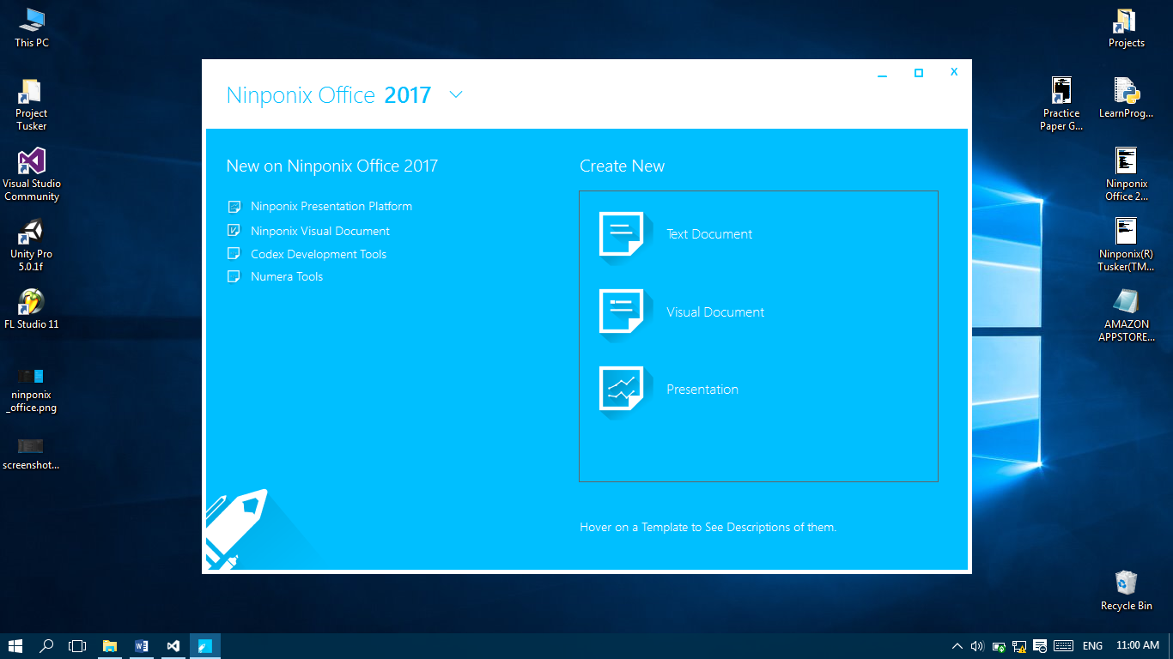

1 – (Menu Controller): Shows and hides the main menu when the user hovers the mouse on it.

2 – (Help Panel): Shows a list of available content for help.

3 – (New Document Panel): A List of available documents that you can engage in creating.

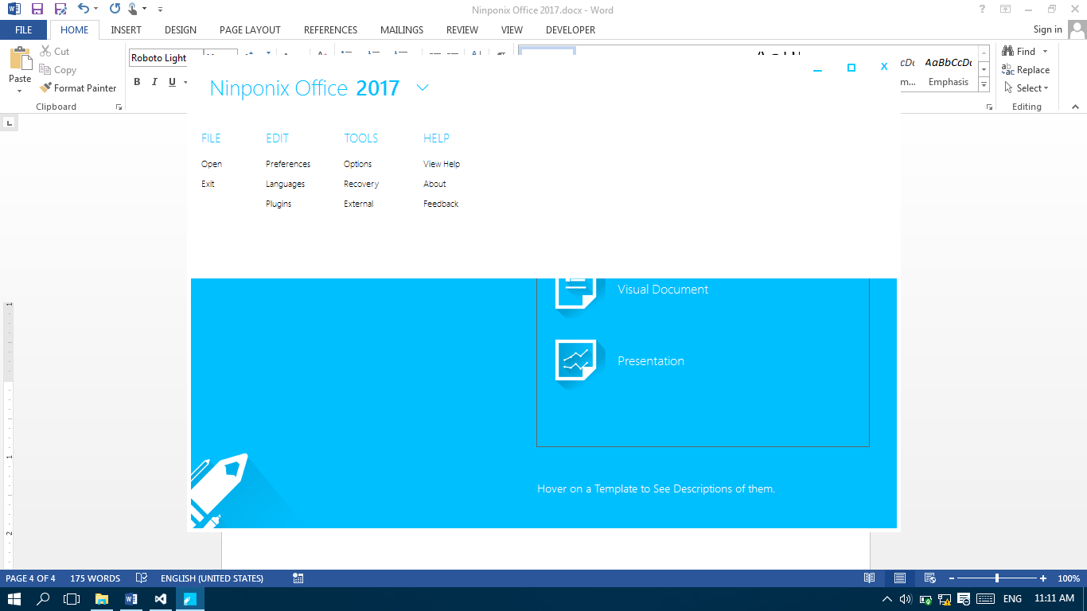

This is the main menu of Ninponix Office 2017,

1. Open: Opens a document selected by the user in a new thread.
2. Exit: Exits the program.
3. Preferences: Enables you to edit your preferences of Ninponix Office 2017 in the options window.
4. Languages: Manage installed languages and change your current selection of languages.
5. Plugins: Install and Uninstall Plugins installed into Ninponix Office 2017.
6. Options: Change settings related to many categories inside Ninponix Office 2017.
7. View Help: Launches this document.
8. About: Shows the credit information of Ninponix Office 2017.
9. Feedback: Emails [c.chamandana@gmail.com](mailto:c.chamandana@gmail.com) in order to give me a feedback.